**What am I going to learn?**

DIV’S and Classes

Cascading Style Sheets

How and why to use tags

Accessibility

How to add hyperlinks

<footer>Hyperlinks</footer>

<section>DIV</section>

<header>IMAGES</header>

<title>CSS</title>

<h2>TAGS</h2>

What does HTML look like?

<h1>HTML</h1>

**The CSS Box Model**

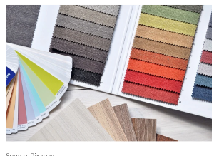

* Can you link your Art and DT design skills to create aesthetically pleasing websites that meet the target audiences’ requirements?

**ASSESSMENT OF YOUR PROJECT**

You will create your own ecommerce webpage to show all the skills you have learnt this term. Good luck and have fun!

**CSS**

* CSS stands for Cascading Style Sheets
* CSS describes how HTML elements are to be displayed

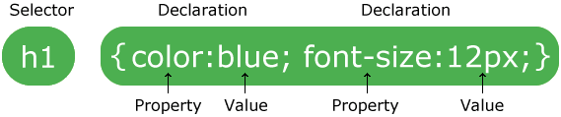

**DIV’S and Classes**

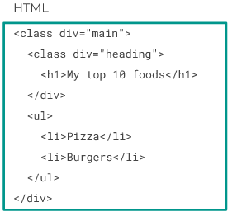

**Succeed and Thrive**

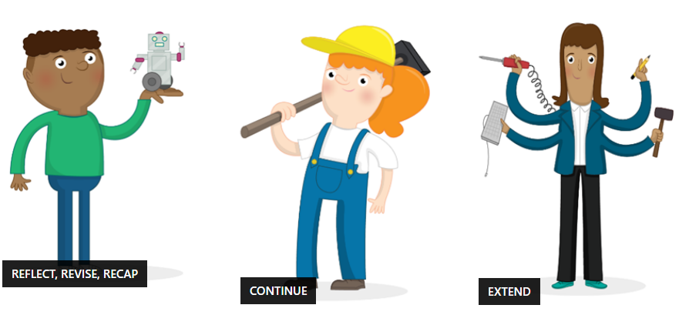

**IMAGES AND LINKS**

Images are not technically inserted into a web page; images are linked to web pages. This is important for accessibility.

The <img> tag creates a holding space for the referenced image.

**MINI PROJECT**

Create a website for a local business = ecommerce

**INTRO TO HTML**

* **HTML** stands for **H**yper **T**ext **M**arkup **L**anguage.
* HTML elements are the bulding blocks of HTML pages.
* HTML is the code behind webpages.

**The History of Webpages**

**1960** – Only the military, scientists and the government used the internet. By **1996** the general public are hosting their own websites.

**DISCUSS AND DEBATE**

* How has the web evolved sin 1960?
* How does this link in with historical/political events of the time?
* Has the web had a positive or negative effect on our wellbeing?

<h1>This is a Heading</h1>