# **Starter activity**

## **Select the correct label from the list below.**

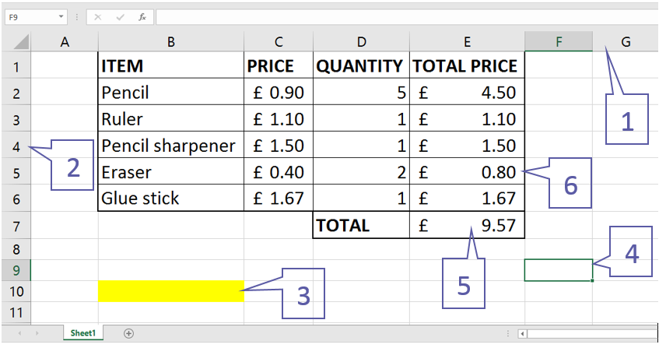

| Active cell | Column | Cell B10 | Row |
| --- | --- | --- | --- |

1. What is the formula in this cell?
2. What is the formula in this cell?

## **What is wrong with this spreadsheet?**

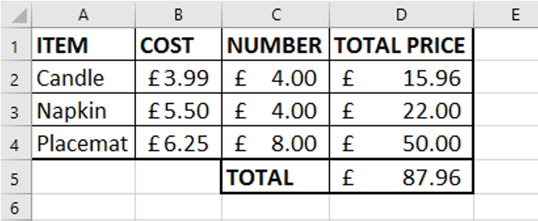

Resources are updated regularly — the latest version is available at: [ncce.io/tcc](http://ncce.io/tcc).

This resource is licensed under the Open Government Licence, version 3. For more information on this licence, see [ncce.io/ogl](http://ncce.io/ogl).